Product Description

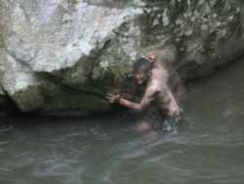 Escape, Evasion & Invisibility aka
“Realm of the Native Scout”
Stealth – Awareness – Survival – Self-Reliance
Class Length: 6 Days (Saturday – Friday)
Class Dates: June 4 – 10, 2016 (Friday evening to Sunday afternoon)
Price $845
Class Location: Smokey Mountains (near Ashville, NC)
Prerequisites: None
Class Description
Stealth – Awareness – Survival – Self-Reliance
Native American Scouts were the eyes and ears of their tribes. Their highly honed Survival and heightened Awareness skills were critical in insuring the safety of their people. Join us as we re-create this experience in the Great Smoky Mountains of Western North Carolina.
Days will consist of learning and practicing various skills, then perfecting them in a simulated “Real World” situation. You’ll learn how to move through the woods unheard and unseen as your Tribe moves as “one” through the landscape observing nature and neighboring tribes.
These skills are thousands of years old and can be adapted to fit any environment or situation…whether it be an urban, rural or wilderness setting.
This class will be a collaborated class between Midwest Native Skills and Richard Cleveland of Earth School. Come join us for this incredible experience! Reserve your spot today !
Skills you’ll learn during the week include:
• Advanced survival skills
• Advanced awareness exercises and techniques

