Thanks for your order!
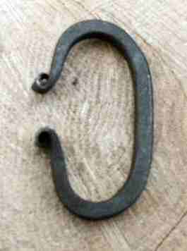
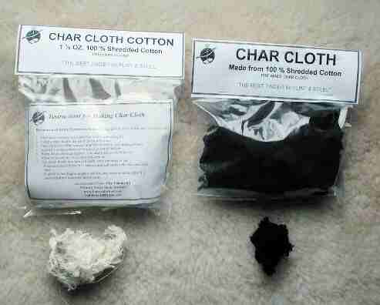
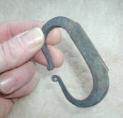
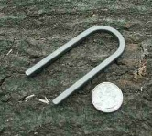
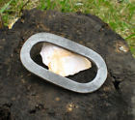
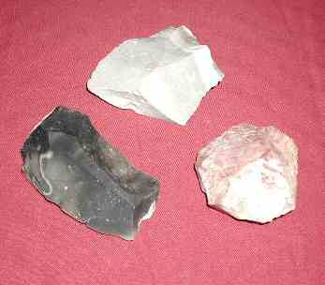
I just thought you might want a see what other we have relating to Fire Making…
Char Cloth - (both pre-made and the raw shredded cotton)
($9.95) ($5.95)
Flint – Brandon, Ohio and Western Chert
Flint & Steel Strikers
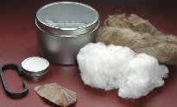
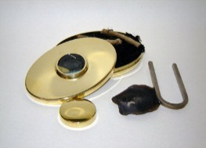
Flint & Steel sets

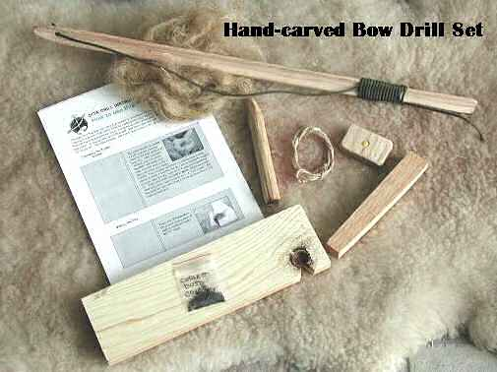
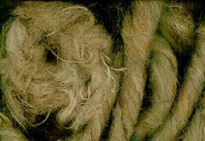
JuteTinder - 200 ft. jute twine spools or 1 gallon bag or bulk 5 lb. box
($3.95) ($7.95) ($39.95)
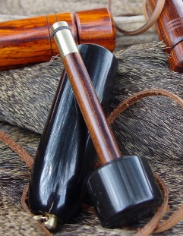
Bow Drill Sets – pretested and ready to make fire!
($29.95)
Hand Drills, Fire Plows, Fire Pistons & Fire Pump Drills…………
Fire Making Videos ($26.95)
- Fire Volume #1 – 1 Match Fires / Flint & Steel / Bow Drill / Hand Drill
- Fire Volume #2 – 40+ Ways to Make Fire Without Matches

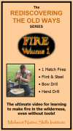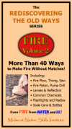

Order at: www.SurvivalSchool.com

