AUTHOR BOOK SIGNING
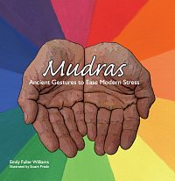
Mudras
by Emily Fuller Williams, LMT

Relieve Stress with Scent, Sound, Self-Massage, and…Mudras
When you're tense with worry about your own life—your relationships, your health, the economy, your work—or when you're tied in knots with "second hand stress" from the people you live with or help in your professional life, there are at least four ways you can relieve these worries.
Mudras is one of the little know cures

